BIT4107 — Mobile Application Development
Week 1 Logbook

Student Name: Joyce Kang’ari

Registration No: BIT/2024/57127

School/Faculty: Information Technology

Programme: BIT4107 – Mobile Application Development

Academic year: 3

Semester: 2

Lecturer:: Mr.Nyoro

Phone Number: 0795585528

Tools I Installed
I installed the following tools on my Windows 11 laptop to get started with Android development:

Tool | What It Is For
Android Studio | The main software I use to write and test my Android app
Java JDK 17 | The Java programming language runtime
Android SDK | Tools and libraries provided by Google to build Android apps
Android Emulator | A virtual phone on my laptop used to test the app without a real device
Gradle | Automatically builds and packages the app when I run it
Git | Used to save and upload my code to GitHub

Installation process of android studio is shown in the screenshot below along with its components.
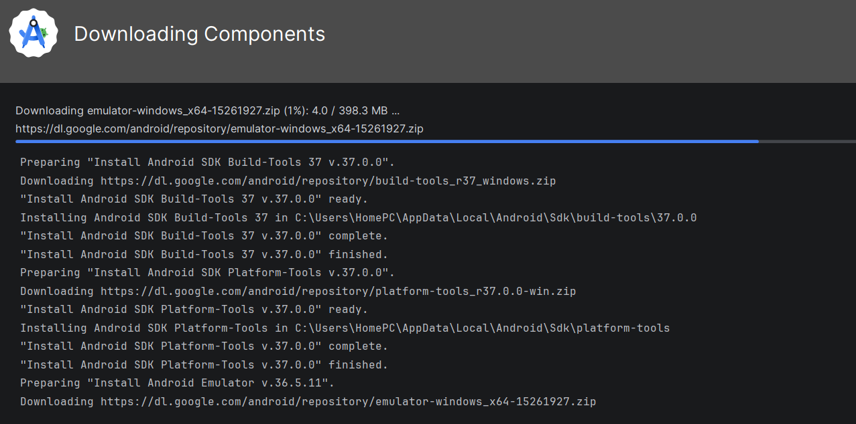
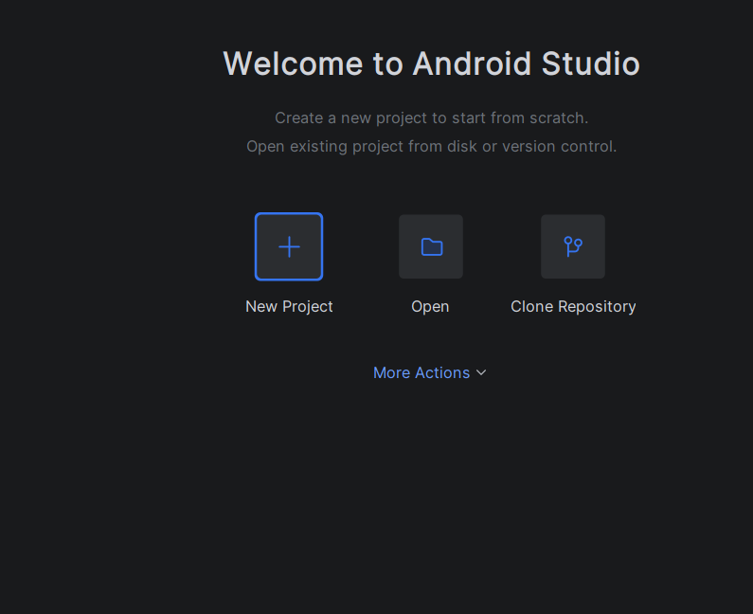

This is after the android studio has completely installed and opened.
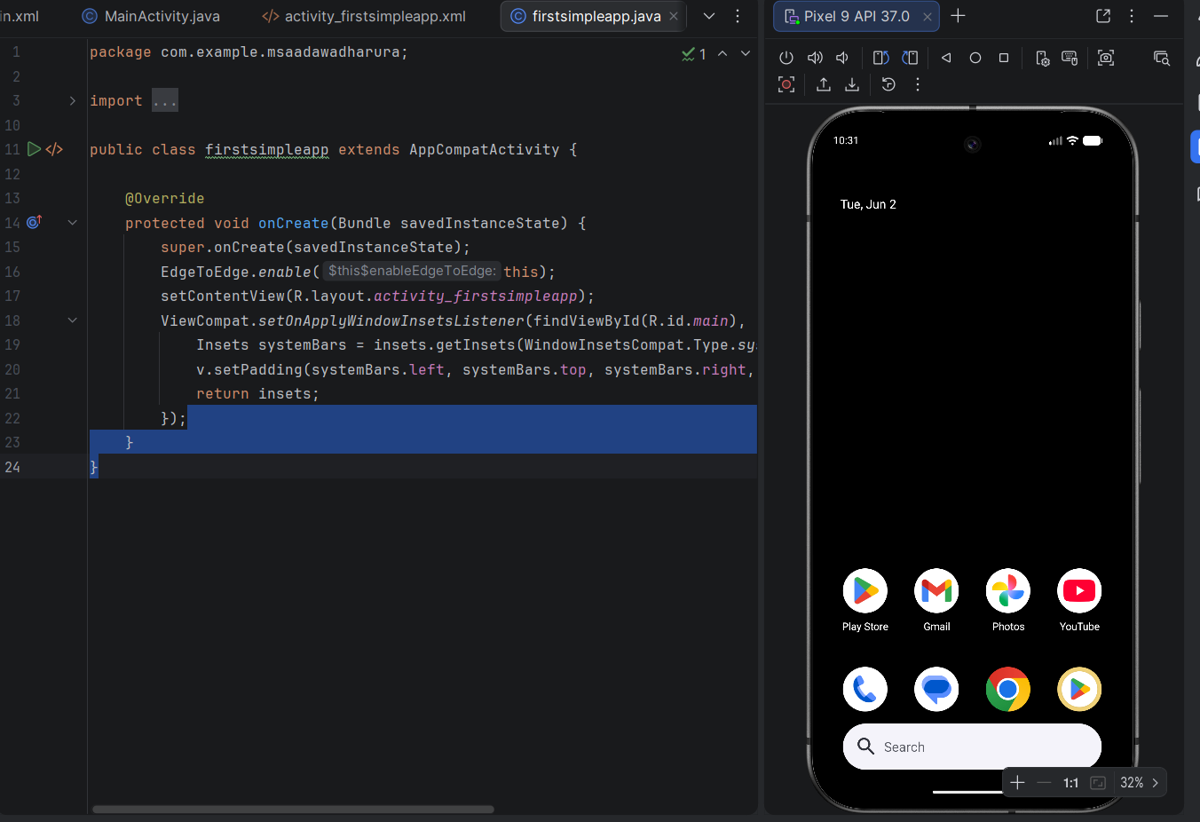
This is after enabling the emulator run in the laptop and it started running as shown above.
WEEK 2
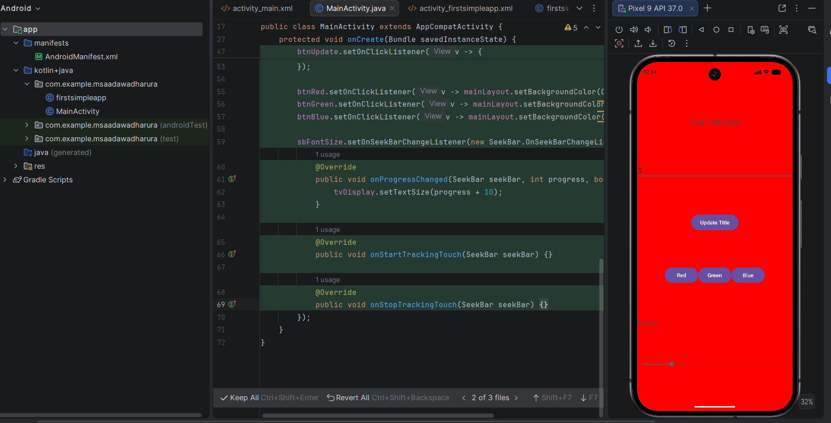
Running a simple code on the Emulator.

Personal reflection
This week taught me a lot about how Android development works. Before this I had only done Java programming for general purposes but now I understand how Java is used specifically to build mobile apps.
I also learned about the difference between native development and cross-platform development. Native apps like the ones built with Java in Android Studio are built specifically for one platform while cross-platform tools like Flutter allow you to build for both Android and iOS from one codebase.

Week 3

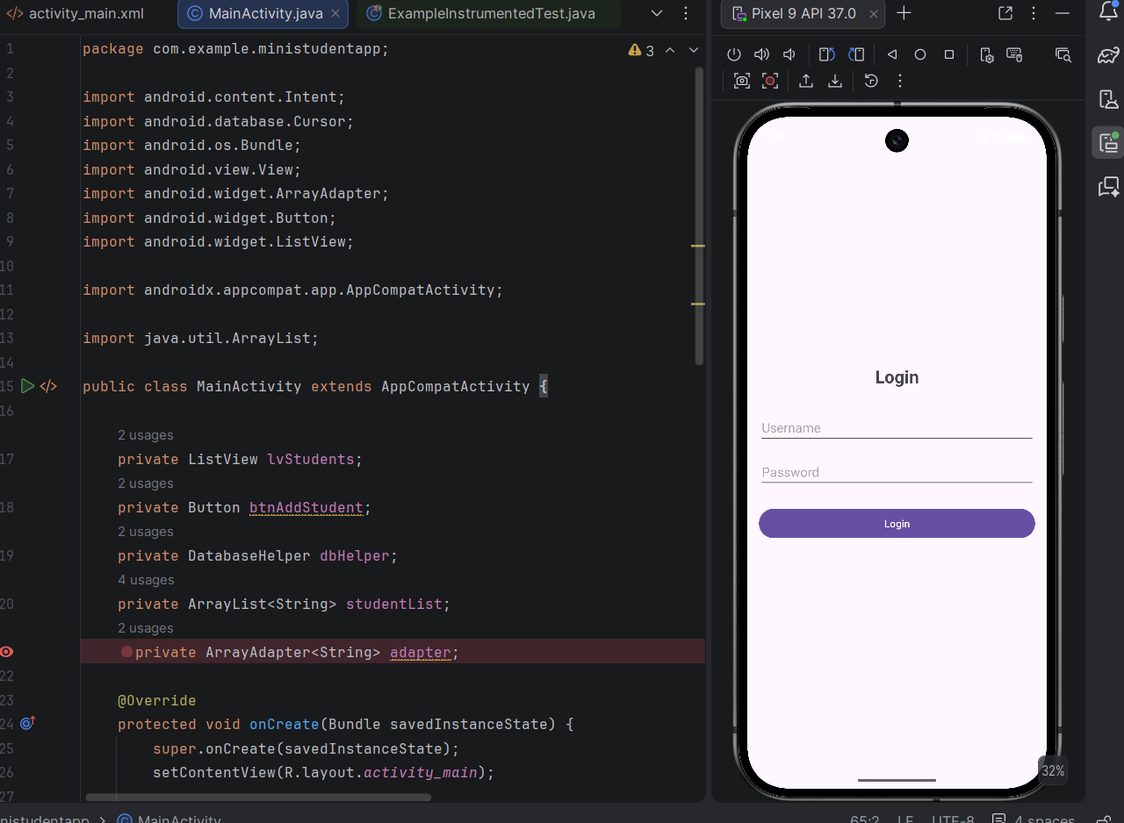
I created a ministudentapp using java
Personal reflection
I never thought that I could actually use java to create an actual app that would run on a mobile phone. In this week I learnt that as long as I knew java as a programming language , I could actually develop actual running apps to be installed in a mobile device.

Week 3
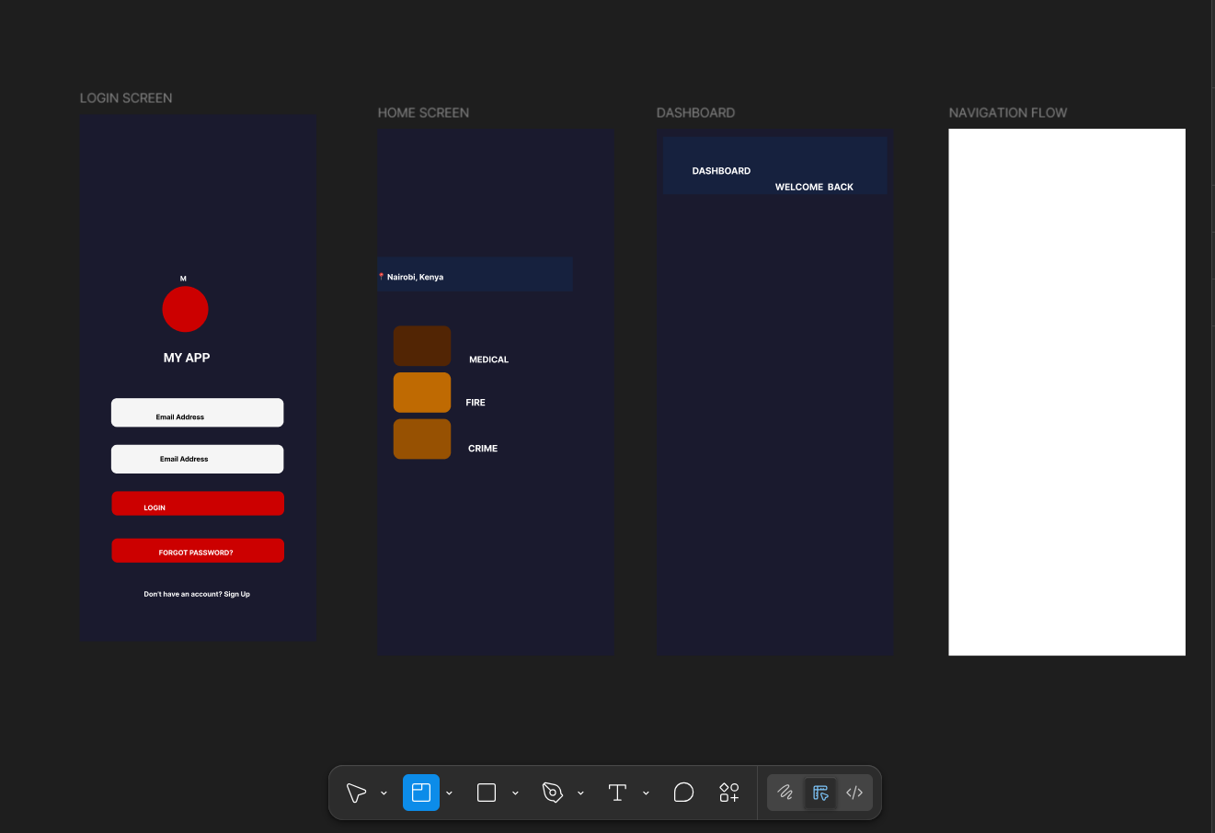
Since I already had a figma account I tried to design a user interface.
I designed a simple design to see if I could actually design the interface of the app I had created and I indeed designed well though the design is not per the app I had created earlier.

Personal reflection
Earlier I didn’t know how to use figma , how to arrange or how to add functionality to it. After continuous practice now I can easily use figma with no difficulty at all. To me that’s an awesome progress.

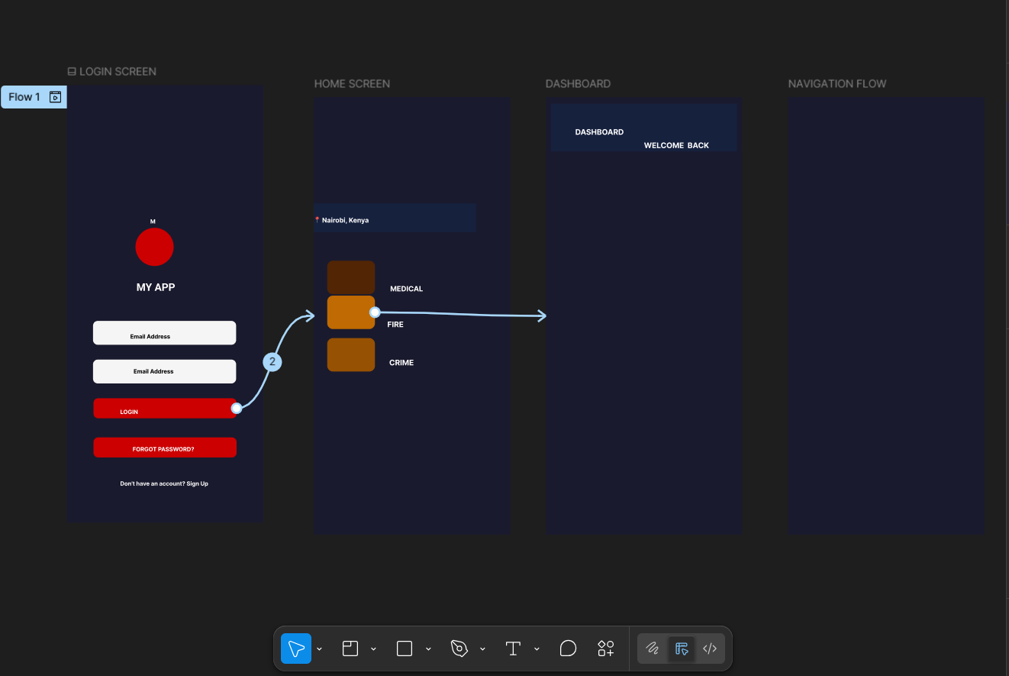
I designed the user design and added functionality to it as the diagram shows.
Am now designing the interface of the student app I had created earlier since now I know how figma works.

Week 4
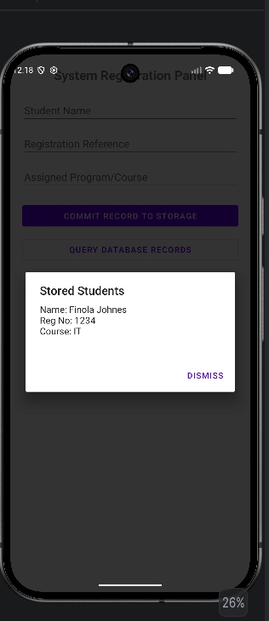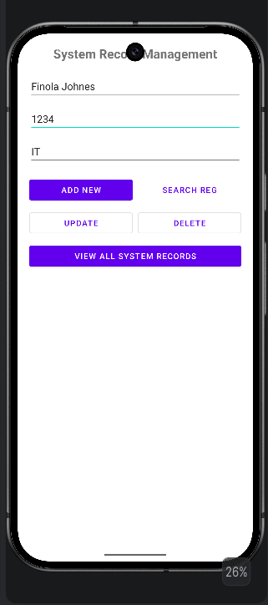
I was able to create a database for my app.
Personal reflection
I was able to know how databases operate in android studio and also you don’t need to install a database app like in vscode because android studio comes with everything ready.

WEEK 5
Networking
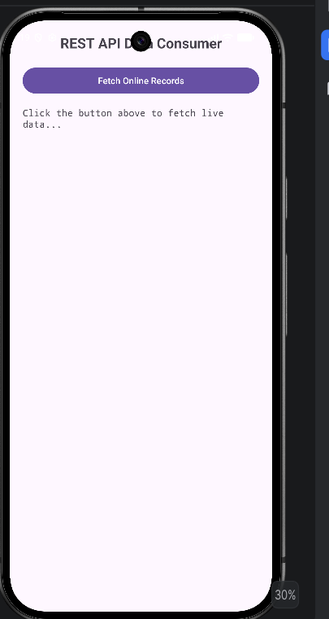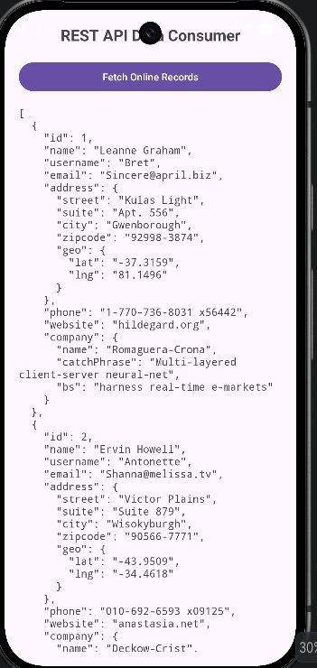
I was able to learn how API’S work.
Personal Reflection
I was able to know that public REST API connects to the internet to fetch and display data. The text view instantly streams a live, structured block of data right from the web server showing names, usernames, and emails in standard JSON format. Didn’t know that API’s could work on mobile apps and with java. I also learn’t that I could zip files to upload them in Github, something I never knew could work.

WEEK 6
why does my app require networking?
In my APIConsumerApp which is shown above, instead of storing thousands of student records on the phone, the app uses an internet connection to send an asynchronous HTTP GET request to a remote REST API endpoint. The server then streams back a lightweight JSON payload which my app parses and displays live on the screen. This keeps the app footprint incredibly small on the phone while providing access to infinite live data.
API Investigation Report
API Name: JSONPlaceholder Test Engine
Purpose: Serving lightweight, mock relational REST endpoints to test background mobile network connections without authentication barriers.
My APIconsumerApp GET Request Example: https://jsonplaceholder.typicode.com/users
WEEK 7
Realised my github link/account was not working when a client I had submitted the link to sent me a message. Panicked but then was also to correct my account and luckily nothing had been lost.

